**Project Initialization and Planning Phase**

| Date | 5 June 2024 |
| --- | --- |
| Team ID | 740043 |
| Project Name | Movie Box Office Gross Prediction |
| Maximum Marks | 3 Marks |

**Define Problem Statements (Customer Problem Statement Template):**

Create a problem statement to understand your customer's point of view. The Customer Problem Statement template helps you focus on what matters to create experiences people will love. A well-articulated customer problem statement allows you and your team to find the ideal solution for your customers' challenges. Throughout the process, you’ll also be able to empathize with your customers, which helps you better understand how they perceive your product or service.

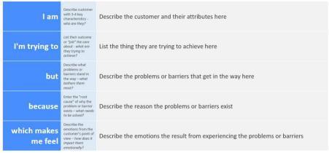

Reference: https://miro.com/templates/customer-problem-statement/

**Example:**



|  |  |  |  |  |  |
| --- | --- | --- | --- | --- | --- |
| **Problem**  **Statement (PS)** | **I am**  **(Customer)** | **I’m trying to** | **But** | **Because** | **Which makes me feel** |
| PS-1 | A movie producer | Accurately predict box office gross | I lack reliable data and analysis method are often inaccurate | There are numerous unpredictable factors affecting movie performance | Uncertain and anxious about the financial success of the film |
| PS-2 | A studio executive | Maximize the profitability of a movie | The prediction model | They do not account for sudden changes in audience preferences or competitive releases | Frustrated and stressed about potential financial losses |